The 1st FEWIEP Workshop
June 28-29, 2019
UC San Diego, MAE Department
Engineering Building 2 (EBU2) Room 549

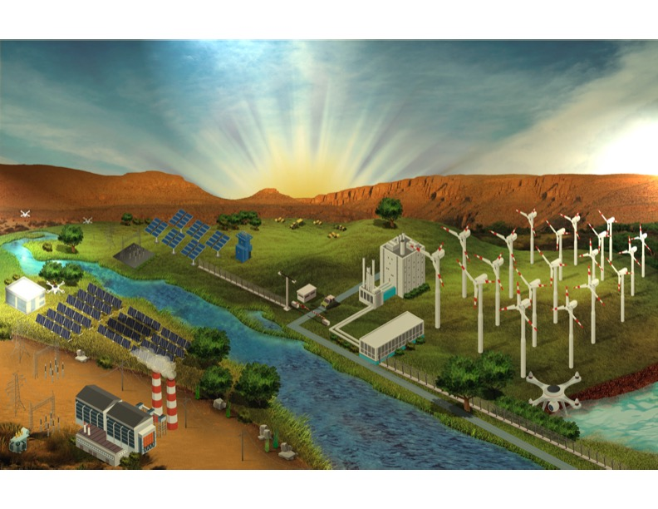
On behalf of the Organizing Committee we would like to welcome you to the 1st Future Energy, Water, Industry, and Economy Park (FEWIEP) workshop to be held at the University of California San Diego during June 28-29, 2019. This workshop represents a follow-up of the FEWIEP White Paper proposal to build an economic corridor along the border states of both sides of the border. During this two-day event, and in partnership with scientists, engineers, investors and developers, we seek to begin the discussion of a plan for the development of the US/Mexico border. Key fundamentals questions will be addressed during the two-day event.

Four goals of the workshop, which are expected to be discussed and addressed, are:

GOAL#1: Development of the Master Vision and Strategic Plan.
GOAL#2: Identification of the region and siting for a 10-mile prototype.
GOAL#3: Establishment of a path for sustainability of FEWIEP Institute(s).
GOAL#4: Expansion of partnership between academia, private, and government sectors of the US and Mexico.

__________________________________
DAY 1: Friday June 28
8:00 - 8:45AM
Continental Breakfast

8:45 – 9:00AM
Welcome & Introductions: Carlos Coimbra (UCSD) & Luciano Castillo (Purdue)
___________________________________________________

Short Talks #1: The Border- Energy Potential & Mexico Perspective

Session Chair:

Angeline Fournier, Maeva/Mexico, and Jay Gore, Purdue/USA
____________________________________________________
9:00 – 9:15 AM
Energy Resources & Water Challenge
Speaker: Luciano Castillo, Purdue, USA

9:15 - 9:30 AM
A Bird’s Eye View of the 1,954-mile Border
Speaker: Ron Adrian, ASU, USA

9:30 – 9:45 AM
The Solar Resource in the SW and the CSP Opportunity
Speaker: Carlos Coimbra, UC San Diego, USA

9:45 – 10:00 AM
Transmission line constraints and opportunities
Speaker: Hanna Greene, PXiSE Energy Solutions, USA

10:00 - 10:15 AM Coffee Break
______________________________________________________
10:15 – 11:00 AM
Power Generation in Mexico
Speaker: Fidelmar Molina, ABB Mexico, S.A.

11:00 – 11:15 AM
Mexico Energy System & US Integration
Speaker: Angeline Fournier, MAEVA Investments, Mexico

11:15 – 11:30 AM Key Outcomes & Discussions of Short Talks #1
Lead: Cataline Stern, UNAM, Mexico

Discussion #1 (GOAL #1): Master Plan Discussion & Charges to Breakout Session
Session Chair: Carlos Coimbra, UC San Diego
Luciano Castillo, Purdue
______________________________________________________
11:30 – 11:45 AM
Example: The Ohio River Bridge Infrastructure & Indiana Toll Road
Speaker: Steve Schultz
A. THE QUESTIONS TO FOCUS
11:45 – 12:00 PM
Breakout Teams:
Example Key Questions:
(a) What is the Problem?
(b) Who is the Project sponsor?

12:00 - 1:00 PM Catered Lunch (on site)
____________________________________
Discussion #1 (continue) and Breakout Session: The Master Plan (Goal #1) and Partnerships (Goal #3)
Session Chair: Ron Adrian, ASU and Luciano Castillo, Purdue

1:00 – 2:45 PM
Outcomes:
Short summary & short presentation debriefs (by team leads).

2:45 - 3:00 PM Coffee Break
____________________________________
Short Talks #2: Project Development & The 10-mile Prototype (Goal #2)
Session Chair:
Carlos Coimbra, UC San Diego and Luciano Castillo, Purdue
3:00 - 3:15 PM
Techno-Economic Analysis
Speaker: Jay Gore, Purdue

3:15 - 3:30 PM
The New RO: A Game Changer on Water and Energy
Speaker: David Warsinger, Purdue

3:30 – 3:45PM
Solar Power and Transmission Lines in the SW
Speaker: Jan Kleissl, UC San Diego

Debriefing & Discussions

3:45 – 4:00PM
Key Outcomes & Discussions of Short Talks #2:
(a) Major outcomes of short talks
(b) Address Key Questions

Discussion #3 (GOALS #2 & #3): Project Key Questions & 10 Miles Prototype

4:00 – 6:00PM
Establishing Sub-teams & breakout teams for Day 2
Lead: Steve Schultz (Purdue) & Luciano Castillo (Purdue)
Key Question:
(a) Address Key Questions
(b) What is the Problem?
(c)Who is the Project sponsor?
______________________________________________________
CLOSING REMARKS:
Carlos Coimbra, University of California- San Diego
6:00PM Adjourn (dinner on your own)

_________________________________
DAY 2: Saturday, June 29
8:00 - 8:45AM Continental Breakfast

Welcome Day #2:
8:45 – 9:00 AM Introduction: Carlos Coimbra, (UCSD)
Major outcomes of day 1: Ron Adrian, ASU
_____________________________________________________
Discussion #4 (GOAL #2 - #5): Project Development & the 10-Mile Prototype
Session Chair: Carlos Coimbra, UC San Diego
Steve Schultz, Purdue
9:00 – 10:30AM
Teams: Technology, Policy & Environment, Economy
Example Key Questions:
(i) Major roadblocks
(ii) Key Next Steps
(iii) What is the “project”?
(iv) Who is the “project sponsor”?

10:30 – 10:45AM Coffee Break

Discussion #5 (GOAL #2 & #3): Key Partnerships & SUSTAINABILITY FEWIEB
10:45AM – 12:00PM
Report Outcomes: Short summaries & short Presentations (by team leads).
______________________________________________________

12:00 - 1:00 PM Lunch

Short Talks #3: Major Technical Challenges & Social Issues

Session Chair:

Catalina Stern, UNAM & Jay Gore, Purdue

1:10 - 1:25 PM
Solar Energy Along the Border & Key Challenges
Speaker: Martin Wosnik, UNH, USA

1:25 – 1:40PM
The Energy Border Fund
Speaker: Eddie Cullen & Derrick Lewis, Border Freedom Capital Solutions LLC
____________________________________________________

2:30 – 2:45 PM Coffee Break

Discussion #6: Address Questions Goals 1-4, Short Summary & Follow Up Event Fall 2019
1:40 – 4:30PM
Discussions:
Establishing sub-teams & breakout teams
Lead: Carlos Coimbra (UCSD) and Luciano Castillo (Purdue)

Key Question:
(a) Address Key Questions
(b) What is the Problem?
(c)Who is the Project sponsor?

CLOSING REMARKS & FOLLOW-UP ITEMS
Carlos Coimbra (UC San Diego) Luciano Castillo (Purdue), Angeline Fournier (MAEVA Investments), Ron Adrian (ASU) and Jay Gore (Purdue)

